ASSIGNMENT 4:

Name: Om Prasanna Kulkarni

PRN: 22510034

Batch: S3

Branch: CSE

Topic: Inheritance and Operator Overloading

Q.1) Write a program to read a list containing item name, item code, and cost interactively and produce a three column output as shown below.

**NAME CODE COST**

Turbo C++ 1001 250.95

C Primer 905 95.70

Note that the name and code are left justified and the cost is right justified with a precision of two digits. Trailing zeros are shown.

Source Code:

#include <iostream>

#include <iomanip>

#include <string>

#include <vector>

using namespace std;

struct Item {

    string name;

    int code;

    double cost;

};

int main() {

    vector<Item> itemList;

    cout << "Enter item details (name, code, cost) or type 'exit' to finish:" << endl;

    while (true) {

        Item newItem;

        string input;

        cout << "Name: ";

        getline(cin, newItem.name);

        if (newItem.name == "exit") {

            break;

        }

        cout << "Code: ";

        cin >> newItem.code;

        cout << "Cost: ";

        cin >> newItem.cost;

        cin.ignore();

        itemList.push_back(newItem);

    }

    cout << left << setw(20) << "NAME" << setw(15) << "CODE" << setw(10) << "COST" << endl;

    for (const Item& item : itemList) {

        cout << left << setw(20) << item.name << setw(15) << item.code << fixed << setprecision(2) << right << setw(10) << item.cost << endl;

    }

    return 0;

}

Output:  
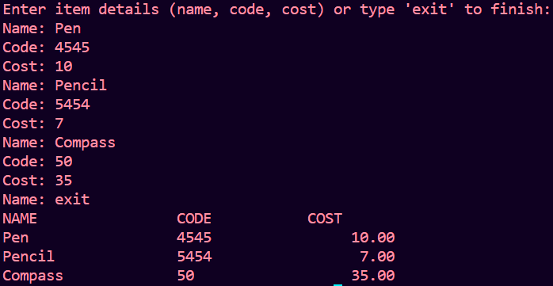

Q.2) Modify the above program to fill the unused spaces with hyphens.

Source Code:

#include <iostream>

#include <iomanip>

#include <string>

#include <vector>

using namespace std;

struct Item {

    string name;

    int code;

    double cost;

};

int main() {

    vector<Item> itemList;

    cout << "Enter item details (name, code, cost) or type 'exit' to finish:" << endl;

    while (true) {

        Item newItem;

        string input;

        cout << "Name: ";

        getline(cin, newItem.name);

        if (newItem.name == "exit") {

            break;

        }

        cout << "Code: ";

        cin >> newItem.code;

        cout << "Cost: ";

        cin >> newItem.cost;

        cin.ignore();

        itemList.push_back(newItem);

    }

    cout << left << setw(20) << "NAME" << setw(15) << "CODE" << setw(10) << "COST" << endl;

    for (const Item& item : itemList) {

        cout << left << setw(20) << item.name << setw(15) << item.code << fixed << setprecision(2) << right << setw(10) << setfill('-') << item.cost << endl;

    }

    return 0;

}

OUTPUT:

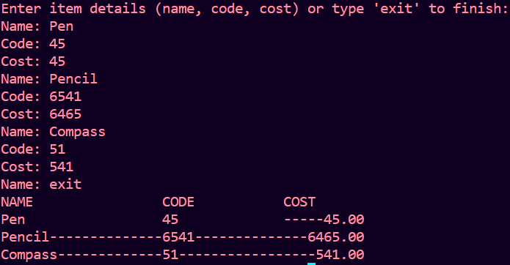

1. Q.3) Write a program which reads a text from the keyboard and displays the following information on the screen in two columns:

(a) Number of lines

(b) Number of words

(c) Number of characters

Strings should be left-justified and numbers should be right-justified in a suitable field width.

Source Code:

#include <iostream>

#include <string>

#include <fstream>

#include <iomanip>

using namespace std;

int main() {

    string text;

    int lineCount = 0;

    int wordCount = 0;

    int charCount = 0;

    cout << "Enter text. Press Ctrl+D (Linux/Mac) or Ctrl+Z (Windows) then Enter to end input:" << endl;

    while (getline(cin, text)) {

        lineCount++;

        charCount += text.length();

        stringstream ss(text);

        string word;

        while (ss >> word) {

            wordCount++;

        }

    }

    cout << left << "Number of lines:" << right << setw(10) << lineCount << endl;

    cout << left << "Number of words:" << right << setw(10) << wordCount << endl;

    cout << left << "Number of characters:" << right << setw(10) << charCount << endl;

    return 0;

}

OUTPUT:

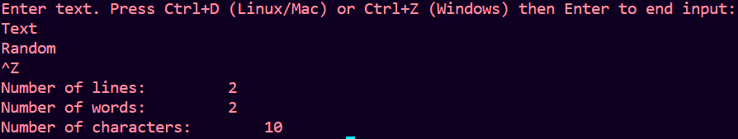

1. Q.4) Write a program that reads a text file and creates another file that is identical except that every sequence of consecutive blank spaces is replaced by a single apace.

Source Code:

#include <iostream>

#include <fstream>

#include <string>

using namespace std;

int main() {

    string inputFileName, outputFileName;

    cout << "Enter the name of the input file: ";

    cin >> inputFileName;

    cout << "Enter the name of the output file: ";

    cin >> outputFileName;

    ifstream inputFile(inputFileName);

    if (!inputFile) {

        cerr << "Error: Unable to open input file." << endl;

        return 1;

    }

    ofstream outputFile(outputFileName);

    if (!outputFile) {

        cerr << "Error: Unable to create output file." << endl;

        return 1;

    }

    char prevChar = '\0';

    char currentChar;

    while (inputFile.get(currentChar)) {

        if (!(prevChar == ' ' && currentChar == ' ')) {

            outputFile.put(currentChar);

        }

        prevChar = currentChar;

    }

    inputFile.close();

    outputFile.close();

    cout << "File transformation complete." << endl;

    return 0;

}

OUTPUT:  
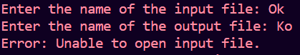

1. Q.5) A file contains a list of telephone numbers in the following form

John 23456

Ahmed 9976

The names contain only one word and the names and telephone numbers are separated by white spaces.

Write a program to read the file and output the list in two columns. The names should be left-justified and the numbers right-justified.

Source Code:

#include <iostream>

#include <fstream>

#include <string>

#include <iomanip>

using namespace std;

int main() {

    string fileName;

    cout << "Enter the name of the file: ";

    cin >> fileName;

    ifstream inputFile(fileName);

    if (!inputFile) {

        cerr << "Error: Unable to open the file." << endl;

        return 1;

    }

    cout << left << setw(20) << "NAME" << "PHONE NUMBER" << endl;

    cout << "------------------------------------------" << endl;

    string name;

    int phoneNumber;

    while (inputFile >> name >> phoneNumber) {

        cout << left << setw(20) << name << right << setw(10) << phoneNumber << endl;

    }

    inputFile.close();

    return 0;

}

OUTPUT:



1. Q.6) Write a program that will create a data file containing the First of telephone numbers given in above example- Use a class object to store each set of data.

Source Code:

1. #include <iostream>
2. #include <fstream>
3. #include <string>
4. using namespace std;
5. class TelephoneEntry {
6. public:
7. string name;
8. int phoneNumber;
9. TelephoneEntry(const string& _name, int _phoneNumber) : name(_name), phoneNumber(_phoneNumber) {}
10. };
11. int main() {
13. TelephoneEntry john("John", 23456);
14. TelephoneEntry ahmed("Ahmed", 9976);
16. ofstream outputFile("telephone_numbers.txt");
17. if (!outputFile) {
18. cerr << "Error: Unable to create the file." << endl;
19. return 1;
20. }
22. outputFile << john.name << " " << john.phoneNumber << endl;
23. outputFile << ahmed.name << " " << ahmed.phoneNumber << endl;
24. outputFile.close();
25. cout << "Data file 'telephone_numbers.txt' created successfully." << endl;
26. return 0;
27. }

OUTPUT:

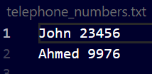

1. Q.7) Write an interactive, menu-driven program that will access the file created above example and implement the following tasks.

(a) Determine the telephone number of the specified person.

(b) Determine the name if a telephone number is known.

(c) Update the telephone number, whenever there is a change

Source Code:

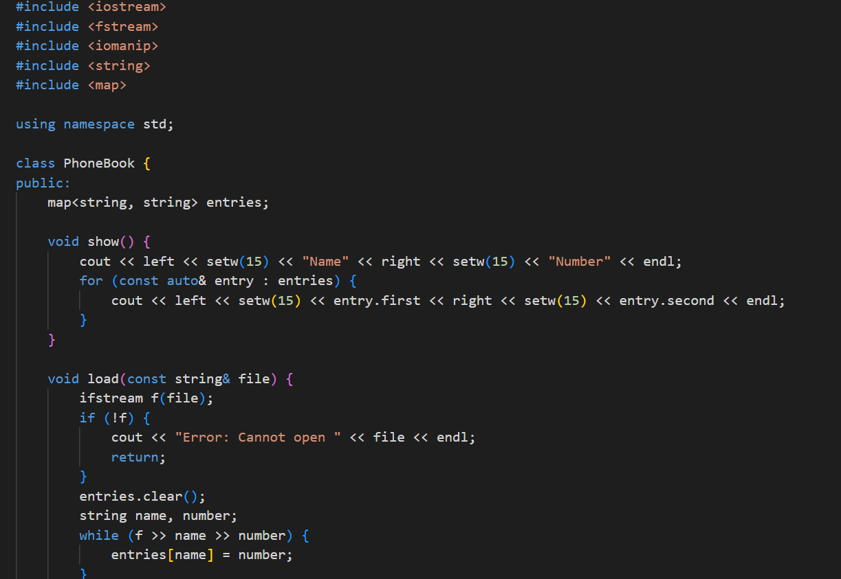

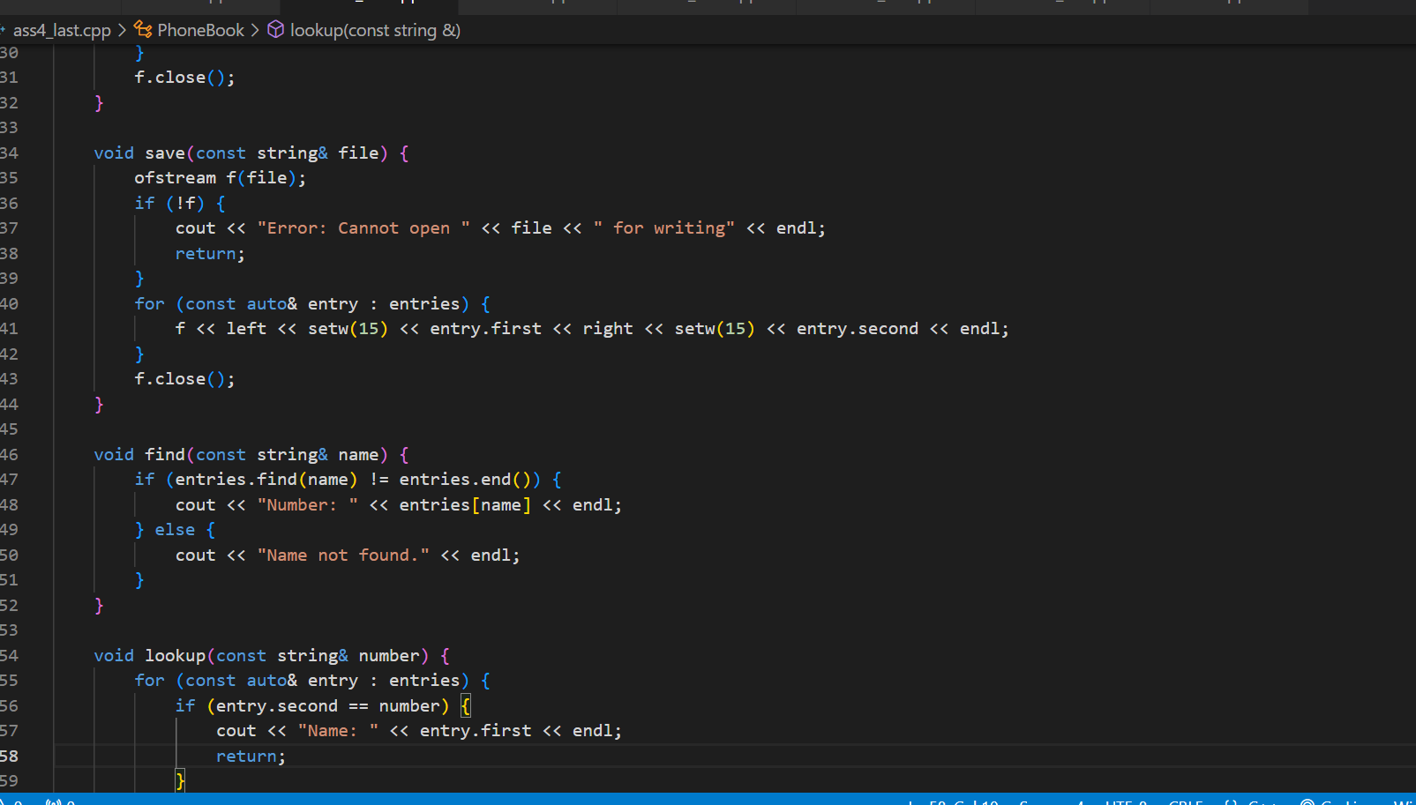

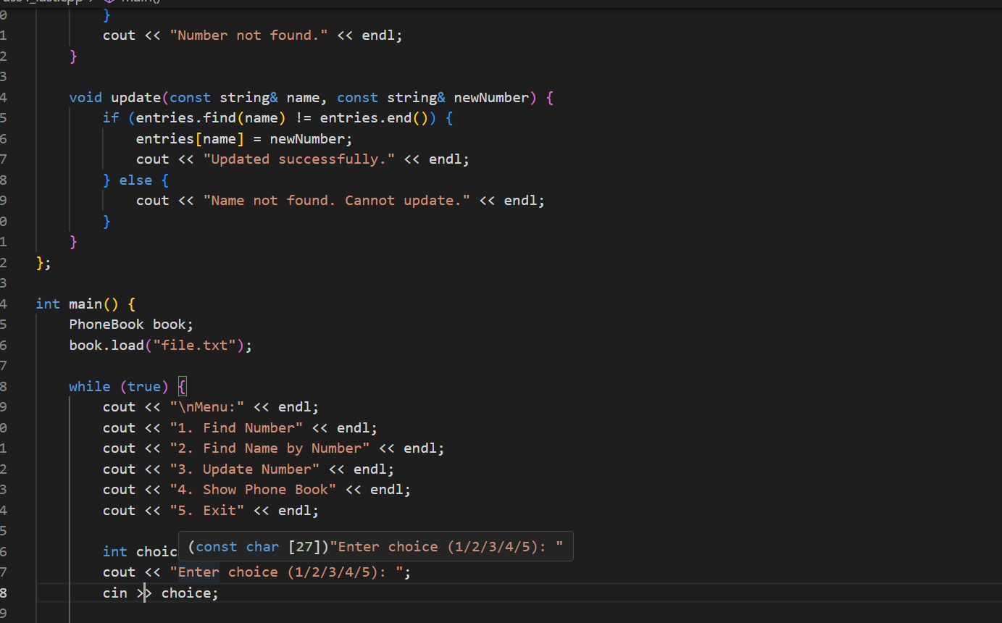

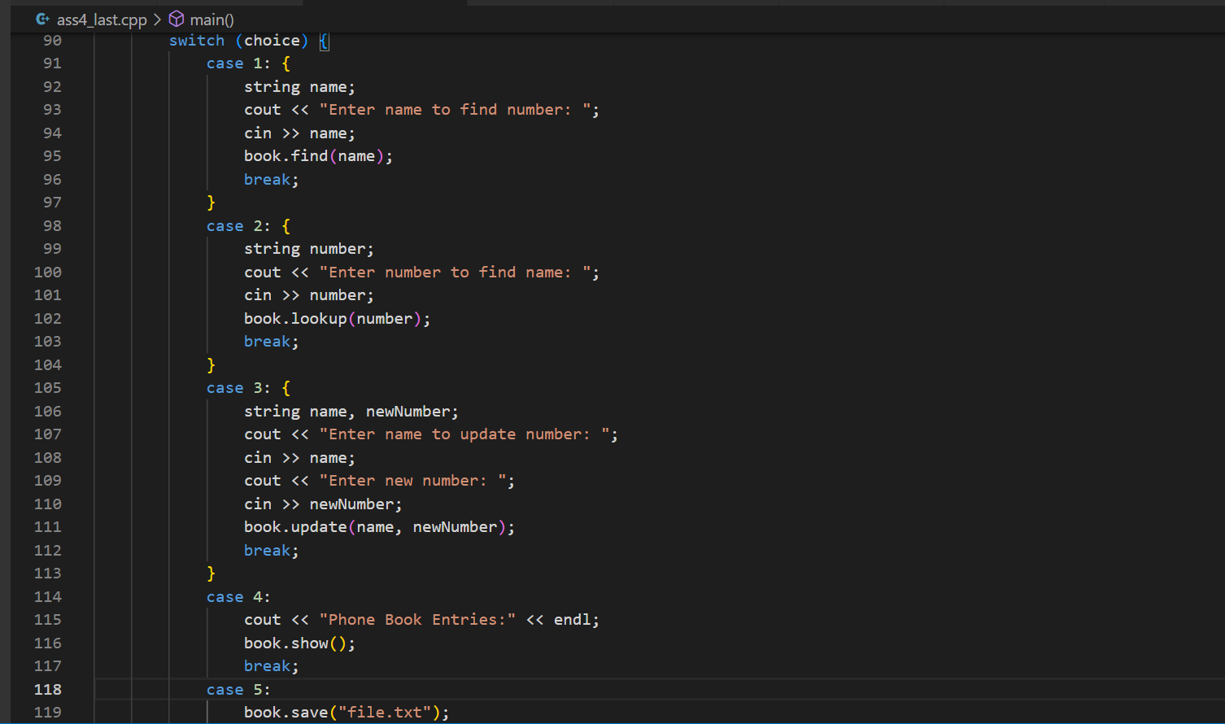

OUTPUT:

